5. Write a program to implement the naïve Bayesian classifier for a sample training data set stored as a .CSV file. Compute the accuracy of the classifier, considering few test data sets.

# Importing the libraries

import numpy as nm

import matplotlib.pyplot as mtp

import pandas as pd

# Importing the dataset

dataset = pd.read_csv('User_Data.csv')

x = dataset.iloc[:, [2, 3]].values

y = dataset.iloc[:, 4].values

# Splitting the dataset into the Training set and Test set

from sklearn.model_selection import train_test_split

x_train, x_test, y_train, y_test = train_test_split(x, y, test_size = 0.25, random_state = 0)

# Feature Scaling

from sklearn.preprocessing import StandardScaler

sc = StandardScaler()

x_train = sc.fit_transform(x_train)

x_test = sc.transform(x_test)

#Displaying the dataset

dataset

OUTPUT:

|  | User ID | Gender | Age | EstimatedSalary | Purchased |
| --- | --- | --- | --- | --- | --- |
| 0 | 15624510 | Male | 19 | 19000 | 0 |
| 1 | 15810944 | Male | 35 | 20000 | 0 |
| 2 | 15668575 | Female | 26 | 43000 | 0 |
| 3 | 15603246 | Female | 27 | 57000 | 0 |
| 4 | 15804002 | Male | 19 | 76000 | 0 |
| ... | ... | ... | ... | ... | ... |
| 395 | 15691863 | Female | 46 | 41000 | 1 |
| 396 | 15706071 | Male | 51 | 23000 | 1 |
| 397 | 15654296 | Female | 50 | 20000 | 1 |
| 398 | 15755018 | Male | 36 | 33000 | 0 |
| 399 | 15594041 | Female | 49 | 36000 | 1 |
|  |  |  |  |  |  |

400 rows × 5 columns

# Fitting Naive Bayes to the Training set

from sklearn.naive_bayes import GaussianNB

classifier = GaussianNB()

classifier.fit(x_train, y_train)

OUTPUT:GaussianNB()

# Predicting the Test set results

y_pred = classifier.predict(x_test)

# Making the Confusion Matrix

from sklearn.metrics import confusion_matrix

cm = confusion_matrix(y_test, y_pred)

print("Confusion Matrix : \n",cm)

OUTPUT: Confusion Matrix :

[[65 3]

[ 7 25]]

# Visualising the Training set results

from matplotlib.colors import ListedColormap

x_set, y_set = x_train, y_train

X1, X2 = nm.meshgrid(nm.arange(start = x_set[:, 0].min() - 1, stop = x_set[:, 0].max() + 1, step = 0.01),

nm.arange(start = x_set[:, 1].min() - 1, stop = x_set[:, 1].max() + 1, step = 0.01))

mtp.contourf(X1, X2, classifier.predict(nm.array([X1.ravel(), X2.ravel()]).T).reshape(X1.shape),

alpha = 0.75, cmap = ListedColormap(('purple', 'green')))

mtp.xlim(X1.min(), X1.max())

mtp.ylim(X2.min(), X2.max())

for i, j in enumerate(nm.unique(y_set)):

mtp.scatter(x_set[y_set == j, 0], x_set[y_set == j, 1],

c = ListedColormap(('purple', 'green'))(i), label = j)

mtp.title('Naive Bayes (Training set)')

mtp.xlabel('Age')

mtp.ylabel('Estimated Salary')

mtp.legend()

mtp.show()

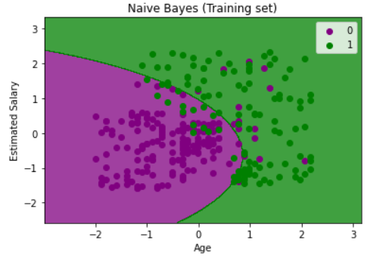

# Visualising the Test set results

from matplotlib.colors import ListedColormap

x_set, y_set = x_test, y_test

X1, X2 = nm.meshgrid(nm.arange(start = x_set[:, 0].min() - 1, stop = x_set[:, 0].max() + 1, step = 0.01),

nm.arange(start = x_set[:, 1].min() - 1, stop = x_set[:, 1].max() + 1, step = 0.01))

mtp.contourf(X1, X2, classifier.predict(nm.array([X1.ravel(), X2.ravel()]).T).reshape(X1.shape),

alpha = 0.75, cmap = ListedColormap(('red', 'green')))

mtp.xlim(X1.min(), X1.max())

mtp.ylim(X2.min(), X2.max())

for i, j in enumerate(nm.unique(y_set)):

mtp.scatter(x_set[y_set == j, 0], x_set[y_set == j, 1],

c = ListedColormap(('red', 'green'))(i), label = j)

mtp.title('Naive Bayes (test set)')

mtp.xlabel('Age')

mtp.ylabel('Estimated Salary')

mtp.legend()

mtp.show()

from sklearn.metrics import accuracy_score

print ("Accuracy : ", accuracy_score(y_test, y_pred))

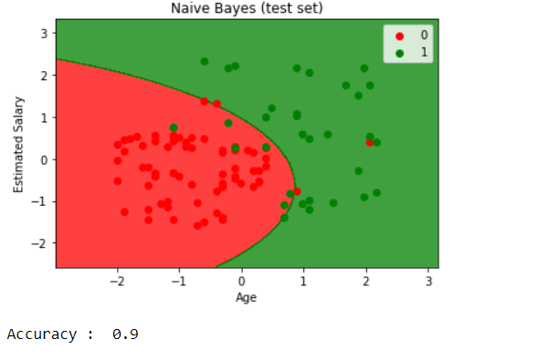

11. Write a Program to Implement travelling salesman problem using Python.

*# Python3 program to implement traveling salesman*

*# problem using naive approach*.

from sys import maxsize

from itertools import permutations

V = 4

*# implementation of traveling Salesman Problem*

def travellingSalesmanProblem(graph, s):

*# store all vertex apart from source vertex*

vertex = []

for i in range(V):

if i != s:

vertex.append(i)

*# store minimum weight Hamiltonian Cycle*

min_path = maxsize

next_permutation=permutations(vertex)

for i in next_permutation:

*# store current Path weight(cost)*

current_pathweight = 0

*# compute current path weight*

k = s

for j in i:

current_pathweight += graph[k][j]

k = j

current_pathweight += graph[k][s]

*# Update minimum*

min_path = min(min_path, current_pathweight)

return min_path

*# Driver Code*

if __name__ == "__main__":

*# matrix representation of graph*

graph = [[0, 10, 15, 20], [10, 0, 35, 25],

[15, 35, 0, 30], [20, 25, 30, 0]]

s = 0

print(travellingSalesmanProblem(graph, s))

Output

80

6. Write a program to implement Logistic regression classifier to find accuracy for training and test fruit data set.

#Data Pre-procesing Step

# importing libraries

import numpy as nm

import matplotlib.pyplot as mtp

import pandas as pd

#importing datasets

data_set= pd.read_csv('User_Data.csv')

data_set

Output:

User ID Gender Age EstimatedSalary Purchased

0 15624510 Male 19 19000 0

1 15810944 Male 35 20000 0

2 15668575 Female 26 43000 0

3 15603246 Female 27 57000 0

4 15804002 Male 19 76000 0

... ... ... ... ... ... ... ...

395 15691863 Female 46 41000 1

396 15706071 Male 51 23000 1

397 15654296 Female 50 20000 1

398 15755018 Male 36 33000 0

399 15594041 Female 49 36000 1

400 rows × 5 columns

#Data Pre-procesing Step

# importing libraries

import numpy as nm

import matplotlib.pyplot as mtp

import pandas as pd

#importing datasets

data_set= pd.read_csv('User_Data.csv')

#Extracting Independent and dependent Variable

x= data_set.iloc[:, [2,3]].values

y= data_set.iloc[:, 4].values

# Splitting the dataset into training and test set.

from sklearn.model_selection import train_test_split

x_train, x_test, y_train, y_test= train_test_split(x, y, test_size= 0.25, random_state=0)

#feature Scaling

from sklearn.preprocessing import StandardScaler

st_x= StandardScaler()

x_train= st_x.fit_transform(x_train)

x_test= st_x.transform(x_test)

#Fitting Logistic Regression to the training set

from sklearn.linear_model import LogisticRegression

classifier= LogisticRegression(random_state=0)

classifier.fit(x_train, y_train)

LogisticRegression(C=1.0, class_weight=None, dual=False, fit_intercept=True,

                   intercept_scaling=1, l1_ratio=None, max_iter=100,

                   multi_class='warn', n_jobs=None, penalty='l2',

                   random_state=0, solver='warn', tol=0.0001, verbose=0,

                   warm_start=False)

#Predicting the test set result

y_pred= classifier.predict(x_test)

print(y_pred)

Output:

[0 0 0 0 0 0 0 1 0 1 0 0 0 0 0 0 0 0 1 0 0 1 0 1 0 1 0 0 0 0 0 0 1 0 0 0 0

0 0 1 0 0 0 0 1 0 0 1 0 1 1 0 0 0 1 0 0 0 0 0 0 1 0 0 0 1 0 0 0 0 1 0 0 0

0 0 1 0 1 1 1 1 0 0 1 1 0 1 0 0 0 1 0 0 0 0 0 0 1 1]

#Creating the Confusion matrix

from sklearn.metrics import confusion_matrix

cm= confusion_matrix(y_test, y_pred)

print("Confusion Matrix : \n",cm)

Confusion Matrix :

[[65 3]

[ 8 24]]

#Visualizing the training set result

from matplotlib.colors import ListedColormap

x_set, y_set = x_train, y_train

x1, x2 = nm.meshgrid(nm.arange(start = x_set[:, 0].min() - 1, stop = x_set[:, 0].max() + 1, step  =0.01),

nm.arange(start = x_set[:, 1].min() - 1, stop = x_set[:, 1].max() + 1, step = 0.01))

mtp.contourf(x1, x2, classifier.predict(nm.array([x1.ravel(), x2.ravel()]).T).reshape(x1.shape),

alpha = 0.75, cmap = ListedColormap(('purple','green' )))

mtp.xlim(x1.min(), x1.max())

mtp.ylim(x2.min(), x2.max())

for i, j in enumerate(nm.unique(y_set)):

    mtp.scatter(x_set[y_set == j, 0], x_set[y_set == j, 1],

       c = ListedColormap(('purple', 'green'))(i), label = j)

mtp.title('Logistic Regression (Training set)')

mtp.xlabel('Age')

mtp.ylabel('Estimated Salary')

mtp.legend()

mtp.show()

Output:

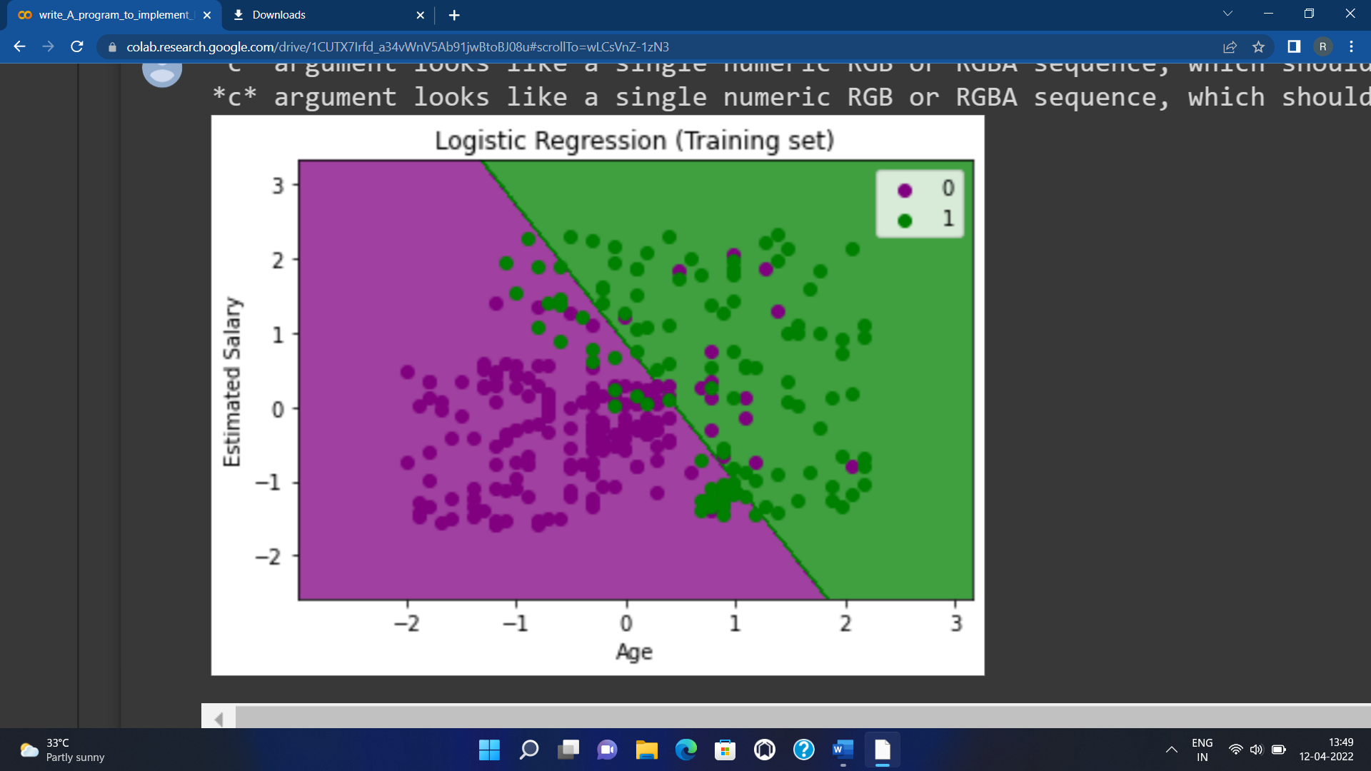

#Visulaizing the test set result

from matplotlib.colors import ListedColormap

x_set, y_set = x_test, y_test

x1, x2 = nm.meshgrid(nm.arange(start = x_set[:, 0].min() - 1, stop = x_set[:, 0].max() + 1, step  =0.01),

nm.arange(start = x_set[:, 1].min() - 1, stop = x_set[:, 1].max() + 1, step = 0.01))

mtp.contourf(x1, x2, classifier.predict(nm.array([x1.ravel(), x2.ravel()]).T).reshape(x1.shape),

alpha = 0.75, cmap = ListedColormap(('purple','green' )))

mtp.xlim(x1.min(), x1.max())

mtp.ylim(x2.min(), x2.max())

for i, j in enumerate(nm.unique(y_set)):

    mtp.scatter(x_set[y_set == j, 0], x_set[y_set == j, 1],

        c = ListedColormap(('purple', 'green'))(i), label = j)

mtp.title('Logistic Regression (Test set)')

mtp.xlabel('Age')

mtp.ylabel('Estimated Salary')

mtp.legend()

mtp.show()

from sklearn.metrics import accuracy_score

print ("Accuracy : ", accuracy_score(y_test, y_pred))

Output:

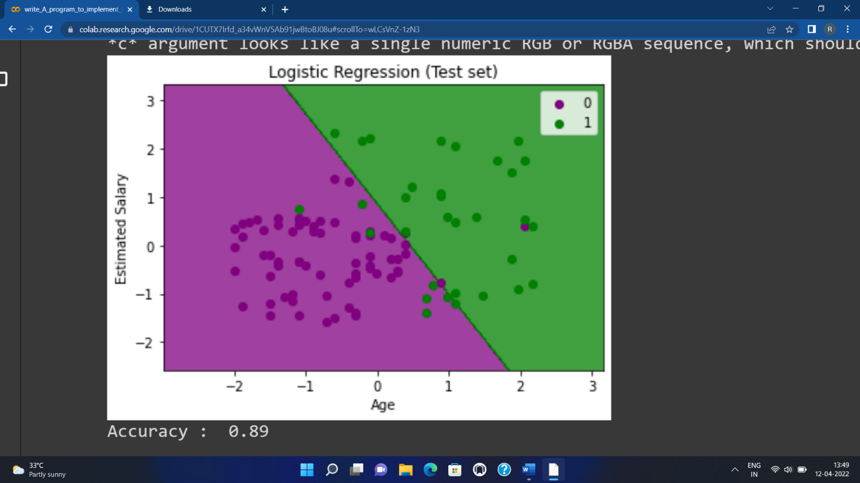

Accuracy : 0.89

4. Build an Artificial Neural Network by implementing the Backpropagation algorithm and test the same using appropriate data sets.

import numpy as np

X = np.array(([2, 9], [1, 5], [3, 6]), dtype=float)

y = np.array(([92], [86], [89]), dtype=float)

X = X/np.amax(X,axis=0) # maximum of X array longitudinally

y = y/100

#Sigmoid Function

def sigmoid (x):

return 1/(1 + np.exp(-x))

#Derivative of Sigmoid Function

def derivatives_sigmoid(x):

return x * (1 - x)

#Variable initialization

epoch=7000 #Setting training iterations

lr=0.1 #Setting learning rate

inputlayer_neurons = 2 #number of features in data set

hiddenlayer_neurons = 3 #number of hidden layers neurons

output_neurons = 1 #number of neurons at output layer

#weight and bias initialization

wh=np.random.uniform(size=(inputlayer_neurons,hiddenlayer_neurons))

bh=np.random.uniform(size=(1,hiddenlayer_neurons))

wout=np.random.uniform(size=(hiddenlayer_neurons,output_neurons))

bout=np.random.uniform(size=(1,output_neurons))

#draws a random range of numbers uniformly of dim x*y

for i in range(epoch):

#Forward Propogation

hinp1=np.dot(X,wh)

hinp=hinp1 + bh

hlayer_act = sigmoid(hinp)

outinp1=np.dot(hlayer_act,wout)

outinp= outinp1+ bout

output = sigmoid(outinp)

#Backpropagation

EO = y-output

outgrad = derivatives_sigmoid(output)

d_output = EO* outgrad

EH = d_output.dot(wout.T)

hiddengrad = derivatives_sigmoid(hlayer_act) #how much hidden layer wts contributed to error

d_hiddenlayer = EH * hiddengrad

wout += hlayer_act.T.dot(d_output) *lr # dotproduct of nextlayererror and currentlayerop

# bout += np.sum(d_output, axis=0,keepdims=True) *lr

wh += X.T.dot(d_hiddenlayer) *lr

#bh += np.sum(d_hiddenlayer, axis=0,keepdims=True) *lr

print("Input: \n" + str(X))

print("Actual Output: \n" + str(y))

print("Predicted Output: \n",output)

Output:

Input:

[[0.66666667 1. ]

[0.33333333 0.55555556]

[1. 0.66666667]]

Actual Output:

[[0.92]

[0.86]

[0.89]]

Predicted Output:

[[0.8946056 ]

[0.88075857]

[0.89439617]]

PART B:

1.Implement and demonstrate the Find-S Algorithm for finding the most specific hypothesis based on a given set of training data samples. Read the training data from a .CSV file

import csv

hypo=['%','%','%','%','%','%']

with open('Training_examples.csv') as csv_file:

readcsv = csv.reader(csv_file, delimiter=',')

data=[]

print("\nThe given training examples are:")

for row in readcsv:

print(row)

if row[len(row)-1] =='Yes':

data.append(row)

print("\nThe positive examples are:")

for x in data:

print(x)

TotalExamples=len(data)

i=0

j=0

k=0

print("\nThe steps of the Find-s algorithm are\n",hypo)

list =[]

p=0

d=len(data[p])-1

for j in range(d):

list.append(data[i][j])

hypo=list

for i in range(1,TotalExamples):

for k in range(d):

if hypo[k]!=data[i][k]:

hypo[k]='?'

else:

hypo[k]

print(hypo)

print("\nThe maximally specific Find-s hypothesis for the given training examples is");

list=[]

for i in range(d):

list.append(hypo[i])

print(list)

OUTPUT:

The given training examples are:

['Sunny', 'Warm', 'Normal', 'Strong', 'Warm', 'Same', 'Yes']

['Sunny', 'Warm', 'High', 'Strong', 'Warm', 'Same', 'Yes']

['Rainy', 'Cold', 'High', 'Strong', 'Warm', 'Change', 'No']

['Sunny', 'Warm', 'High', 'Strong', 'Cool', 'Change', 'Yes']

The positive examples are:

['Sunny', 'Warm', 'Normal', 'Strong', 'Warm', 'Same', 'Yes']

['Sunny', 'Warm', 'High', 'Strong', 'Warm', 'Same', 'Yes']

['Sunny', 'Warm', 'High', 'Strong', 'Cool', 'Change', 'Yes']

The steps of the Find-s algorithm are

['%', '%', '%', '%', '%', '%']

['Sunny', 'Warm', '?', 'Strong', 'Warm', 'Same']

['Sunny', 'Warm', '?', 'Strong', '?', '?']

The maximally specific Find-s hypothesis for the given training examples is

['Sunny', 'Warm', '?', 'Strong', '?', '?']

**6. Write a Program to Implement Tower of Hanoi using Python.**

def  TowerOfHanoi(n , source, destination, auxiliary):

if n==1:

print ("Move disk 1 from source",source,"to destination",destination)

return

TowerOfHanoi(n-1, source, auxiliary, destination)

print ("Move disk",n,"from source",source,"to destination",destination)

TowerOfHanoi(n-1, auxiliary, destination, source)

n = 3

TowerOfHanoi(n,'A','B','C')

**OUTPUT:**

Move disk 1 from source A to destination B

Move disk 2 from source A to destination C

Move disk 1 from source B to destination C

Move disk 3 from source A to destination B

Move disk 1 from source C to destination A

Move disk 2 from source C to destination B

Move disk 1 from source A to destination B

7 write a program to implement N queen problem using python

global N

N = 4

def printSolution(board):

  for i in range(N):

    for j in range(N):

      print (board[i][j], end = " ")

    print()

def isSafe(board, row, col):

  for i in range(col):

    if board[row][i] == 1:

      return False

  for i, j in zip(range(row, -1, -1),

          range(col, -1, -1)):

    if board[i][j] == 1:

      return False

  for i, j in zip(range(row, N, 1),

          range(col, -1, -1)):

    if board[i][j] == 1:

      return False

  return True

def solveNQUtil(board, col):

  if col >= N:

    return True

  for i in range(N):

    if isSafe(board, i, col):

      board[i][col] = 1

      if solveNQUtil(board, col + 1) == True:

        return True

      board[i][col] = 0

  return False

def solveNQ():

  board = [ [0, 0, 0, 0],

      [0, 0, 0, 0],

      [0, 0, 0, 0],

      [0, 0, 0, 0] ]

  if solveNQUtil(board, 0) == False:

    print ("Solution does not exist")

    return False

  printSolution(board)

  return True

solveNQ()

**output:**

0 0 1 0

1 0 0 0

0 0 0 1

0 1 0 0

True

**9.Write a program to implement AO * algorithm in python.**

class Graph:

def __init__(self, graph, heuristicNodeList, startNode):

self.graph = graph

self.H=heuristicNodeList

self.start=startNode

self.parent={}

self.status={}

self.solutionGraph={}

def applyAOStar(self):

self.aoStar(self.start, False)

def getNeighbors(self, v):

return self.graph.get(v,'')

def getStatus(self,v):

return self.status.get(v,0)

def setStatus(self,v, val):

self.status[v]=val

def getHeuristicNodeValue(self, n):

return self.H.get(n,0)

def setHeuristicNodeValue(self, n, value):

self.H[n]=value

def printSolution(self):

print("FOR GRAPH SOLUTION, TRAVERSE THE GRAPH FROM THE START NODE:",self.start)

print("------------------------------------------------------------")

print(self.solutionGraph)

print("------------------------------------------------------------")

def computeMinimumCostChildNodes(self, v):

minimumCost=0

costToChildNodeListDict={}

costToChildNodeListDict[minimumCost]=[]

flag=True

for nodeInfoTupleList in self.getNeighbors(v):

cost=0

nodeList=[]

for c, weight in nodeInfoTupleList:

cost=cost+self.getHeuristicNodeValue(c)+weight

nodeList.append(c)

if flag==True:

minimumCost=cost

costToChildNodeListDict[minimumCost]=nodeList

flag=False

else:

if minimumCost>cost:

minimumCost=cost

costToChildNodeListDict[minimumCost]=nodeList

return minimumCost, costToChildNodeListDict[minimumCost]

def aoStar(self, v, backTracking):

print("HEURISTIC VALUES :", self.H)

print("SOLUTION GRAPH :", self.solutionGraph)

print("PROCESSING NODE :", v)

print("-----------------------------------------------------------------------------------------")

if self.getStatus(v) >= 0:

minimumCost, childNodeList = self.computeMinimumCostChildNodes(v)

print(minimumCost, childNodeList)

self.setHeuristicNodeValue(v, minimumCost)

self.setStatus(v,len(childNodeList))

solved=True

for childNode in childNodeList:

self.parent[childNode]=v

if self.getStatus(childNode)!=-1:

solved=solved & False

if solved==True:

self.setStatus(v,-1)

self.solutionGraph[v]=childNodeList

if v!=self.start:

self.aoStar(self.parent[v], True)

if backTracking==False:

for childNode in childNodeList:

self.setStatus(childNode,0)

self.aoStar(childNode, False)

print ("Graph - 1")

h1 = {'A': 1, 'B': 6, 'C': 2, 'D': 12, 'E': 2, 'F': 1, 'G': 5, 'H': 7, 'I': 7, 'J': 1}

graph1 = {

'A': [[('B', 1), ('C', 1)], [('D', 1)]],

'B': [[('G', 1)], [('H', 1)]],

'C': [[('J', 1)]],

'D': [[('E', 1), ('F', 1)]],

'G': [[('I', 1)]]

}

G1= Graph(graph1, h1, 'A')

G1.applyAOStar()

G1.printSolution()

**OUTPUT :**

Graph - 1

HEURISTIC VALUES : {'A': 1, 'B': 6, 'C': 2, 'D': 12, 'E': 2, 'F': 1, 'G': 5, 'H': 7, 'I': 7, 'J': 1}

SOLUTION GRAPH : {}

PROCESSING NODE : A

-----------------------------------------------------------------------------------------

10 ['B', 'C']

HEURISTIC VALUES : {'A': 10, 'B': 6, 'C': 2, 'D': 12, 'E': 2, 'F': 1, 'G': 5, 'H': 7, 'I': 7, 'J': 1}

SOLUTION GRAPH : {}

PROCESSING NODE : B

-----------------------------------------------------------------------------------------

6 ['G']

HEURISTIC VALUES : {'A': 10, 'B': 6, 'C': 2, 'D': 12, 'E': 2, 'F': 1, 'G': 5, 'H': 7, 'I': 7, 'J': 1}

SOLUTION GRAPH : {}

PROCESSING NODE : A

-----------------------------------------------------------------------------------------

10 ['B', 'C']

HEURISTIC VALUES : {'A': 10, 'B': 6, 'C': 2, 'D': 12, 'E': 2, 'F': 1, 'G': 5, 'H': 7, 'I': 7, 'J': 1}

SOLUTION GRAPH : {}

PROCESSING NODE : G

-----------------------------------------------------------------------------------------

8 ['I']

HEURISTIC VALUES : {'A': 10, 'B': 6, 'C': 2, 'D': 12, 'E': 2, 'F': 1, 'G': 8, 'H': 7, 'I': 7, 'J': 1}

SOLUTION GRAPH : {}

PROCESSING NODE : B

-----------------------------------------------------------------------------------------

8 ['H']

HEURISTIC VALUES : {'A': 10, 'B': 8, 'C': 2, 'D': 12, 'E': 2, 'F': 1, 'G': 8, 'H': 7, 'I': 7, 'J': 1}

SOLUTION GRAPH : {}

PROCESSING NODE : A

-----------------------------------------------------------------------------------------

12 ['B', 'C']

HEURISTIC VALUES : {'A': 12, 'B': 8, 'C': 2, 'D': 12, 'E': 2, 'F': 1, 'G': 8, 'H': 7, 'I': 7, 'J': 1}

SOLUTION GRAPH : {}

PROCESSING NODE : I

-----------------------------------------------------------------------------------------

0 []

HEURISTIC VALUES : {'A': 12, 'B': 8, 'C': 2, 'D': 12, 'E': 2, 'F': 1, 'G': 8, 'H': 7, 'I': 0, 'J': 1}

SOLUTION GRAPH : {'I': []}

PROCESSING NODE : G

-----------------------------------------------------------------------------------------

1 ['I']

HEURISTIC VALUES : {'A': 12, 'B': 8, 'C': 2, 'D': 12, 'E': 2, 'F': 1, 'G': 1, 'H': 7, 'I': 0, 'J': 1}

SOLUTION GRAPH : {'I': [], 'G': ['I']}

PROCESSING NODE : B

-----------------------------------------------------------------------------------------

2 ['G']

HEURISTIC VALUES : {'A': 12, 'B': 2, 'C': 2, 'D': 12, 'E': 2, 'F': 1, 'G': 1, 'H': 7, 'I': 0, 'J': 1}

SOLUTION GRAPH : {'I': [], 'G': ['I'], 'B': ['G']}

PROCESSING NODE : A

-----------------------------------------------------------------------------------------

6 ['B', 'C']

HEURISTIC VALUES : {'A': 6, 'B': 2, 'C': 2, 'D': 12, 'E': 2, 'F': 1, 'G': 1, 'H': 7, 'I': 0, 'J': 1}

SOLUTION GRAPH : {'I': [], 'G': ['I'], 'B': ['G']}

PROCESSING NODE : C

-----------------------------------------------------------------------------------------

2 ['J']

HEURISTIC VALUES : {'A': 6, 'B': 2, 'C': 2, 'D': 12, 'E': 2, 'F': 1, 'G': 1, 'H': 7, 'I': 0, 'J': 1}

SOLUTION GRAPH : {'I': [], 'G': ['I'], 'B': ['G']}

PROCESSING NODE : A

-----------------------------------------------------------------------------------------

6 ['B', 'C']

HEURISTIC VALUES : {'A': 6, 'B': 2, 'C': 2, 'D': 12, 'E': 2, 'F': 1, 'G': 1, 'H': 7, 'I': 0, 'J': 1}

SOLUTION GRAPH : {'I': [], 'G': ['I'], 'B': ['G']}

PROCESSING NODE : J

-----------------------------------------------------------------------------------------

0 []

HEURISTIC VALUES : {'A': 6, 'B': 2, 'C': 2, 'D': 12, 'E': 2, 'F': 1, 'G': 1, 'H': 7, 'I': 0, 'J': 0}

SOLUTION GRAPH : {'I': [], 'G': ['I'], 'B': ['G'], 'J': []}

PROCESSING NODE : C

-----------------------------------------------------------------------------------------

1 ['J']

HEURISTIC VALUES : {'A': 6, 'B': 2, 'C': 1, 'D': 12, 'E': 2, 'F': 1, 'G': 1, 'H': 7, 'I': 0, 'J': 0}

SOLUTION GRAPH : {'I': [], 'G': ['I'], 'B': ['G'], 'J': [], 'C': ['J']}

PROCESSING NODE : A

-----------------------------------------------------------------------------------------

5 ['B', 'C']

FOR GRAPH SOLUTION, TRAVERSE THE GRAPH FROM THE START NODE: A

------------------------------------------------------------

{'I': [], 'G': ['I'], 'B': ['G'], 'J': [], 'C': ['J'], 'A': ['B', 'C']}

**8. Write a program to implement A* algorithm using python.**

class Node():

def __init__(self, parent=None, position=None):

self.parent = parent

self.position = position

self.g = 0

self.h = 0

self.f = 0

def __eq__(self, other):

return self.position == other.position

def astar(maze, start, end):

start_node = Node(None, start)

start_node.g = start_node.h = start_node.f = 0

end_node = Node(None, end)

end_node.g = end_node.h = end_node.f = 0

open_list = []

closed_list = []

open_list.append(start_node)

while len(open_list) > 0:

current_node = open_list[0]

current_index = 0

for index, item in enumerate(open_list):

if item.f < current_node.f:

current_node = item

current_index = index

open_list.pop(current_index)

closed_list.append(current_node)

if current_node == end_node:

path = []

current = current_node

while current is not None:

path.append(current.position)

current = current.parent

return path[::-1] # Return reversed path

children = []

for new_position in [(0, -1), (0, 1), (-1, 0), (1, 0), (-1, -1), (-1, 1), (1, -1), (1, 1)]: # Adjacent squares

node_position = (current_node.position[0] + new_position[0], current_node.position[1] + new_position[1])

if node_position[0] > (len(maze) - 1) or node_position[0] < 0 or node_position[1] > (len(maze[len(maze)-1]) -1) or node_position[1] < 0:

continue

if maze[node_position[0]][node_position[1]] != 0:

continue

new_node = Node(current_node, node_position)

children.append(new_node)

for child in children:

for closed_child in closed_list:

if child == closed_child:

continue

child.g = current_node.g + 1

child.h = ((child.position[0] - end_node.position[0]) ** 2) + ((child.position[1] - end_node.position[1]) ** 2)

child.f = child.g + child.h

for open_node in open_list:

if child == open_node and child.g > open_node.g:

continue

open_list.append(child)

def main():

maze = [[0, 0, 0, 0, 1, 0, 0, 0, 0, 0],

[0, 0, 0, 0, 1, 0, 0, 0, 0, 0],

[0, 0, 0, 0, 1, 0, 0, 0, 0, 0],

[0, 0, 0, 0, 1, 0, 0, 0, 0, 0],

[0, 0, 0, 0, 1, 0, 0, 0, 0, 0],

[0, 0, 0, 0, 0, 0, 0, 0, 0, 0],

[0, 0, 0, 0, 1, 0, 0, 0, 0, 0],

[0, 0, 0, 0, 1, 0, 0, 0, 0, 0],

[0, 0, 0, 0, 1, 0, 0, 0, 0, 0],

[0, 0, 0, 0, 0, 0, 0, 0, 0, 0]]

start = (0, 0)

end = (7, 6)

path = astar(maze, start, end)

print(path)

if __name__ == '__main__':

main()

**OUTPUT:**



[(0, 0), (1, 1), (2, 2),(3, 3), (4, 3), (5, 4), (6, 5), (7, 6)]

**3. Python implementation of automatic Tic Tac Toe game using random number**

import numpy as np

import random

from time import sleep

def create_board():

return(np.array([[0, 0, 0],

[0, 0, 0],

[0, 0, 0]]))

def possibilities(board):

l = []

for i in range(len(board)):

for j in range(len(board)):

if board[i][j] == 0:

l.append((i, j))

return(l)

def random_place(board, player):

selection = possibilities(board)

current_loc = random.choice(selection)

board[current_loc] = player

return(board)

def row_win(board, player):

for x in range(len(board)):

win = True

for y in range(len(board)):

if board[x, y] != player:

win = False

continue

if win == True:

return(win)

return(win)

def col_win(board, player):

for x in range(len(board)):

win = True

for y in range(len(board)):

if board[y][x] != player:

win = False

continue

if win == True:

return(win)

return(win)

def diag_win(board, player):

win = True

y = 0

for x in range(len(board)):

if board[x, x] != player:

win = False

if win:

return win

win = True

if win:

for x in range(len(board)):

y = len(board) - 1 - x

if board[x, y] != player:

win = False

return win

def evaluate(board):

winner = 0

for player in [1, 2]:

if (row_win(board, player) or

col_win(board,player) or

diag_win(board,player)):

winner = player

if np.all(board != 0) and winner == 0:

winner = -1

return winner

def play_game():

board, winner, counter = create_board(), 0, 1

print(board)

sleep(2)

while winner == 0:

for player in [1, 2]:

board = random_place(board, player)

print("Board after " + str(counter) + " move")

print(board)

sleep(2)

counter += 1

winner = evaluate(board)

if winner != 0:

break

return(winner)

print("Winner is: " + str(play_game()))

Output:

[[0 0 0]

[0 0 0]

[0 0 0]]

Board after 1 move

[[0 0 0]

[0 0 0]

[0 0 1]]

Board after 2 move

[[0 0 2]

[0 0 0]

[0 0 1]]

Board after 3 move

[[0 1 2]

[0 0 0]

[0 0 1]]

Board after 4 move

[[0 1 2]

[0 0 2]

[0 0 1]]

Board after 5 move

[[0 1 2]

[0 0 2]

[0 1 1]]

Board after 6 move

[[0 1 2]

[2 0 2]

[0 1 1]]

Board after 7 move

[[0 1 2]

[2 0 2]

[1 1 1]]

Winner is: 1

12.Writea program to implement 8 puzzle problem using python

import copy

from heapq import heappush, heappop

n = 3

row = [ 1, 0, -1, 0 ]

col = [ 0, -1, 0, 1 ]

class priorityQueue:

def __init__(self):

self.heap = []

def push(self, k):

heappush(self.heap, k)

def pop(self):

return heappop(self.heap)

def empty(self):

if not self.heap:

return True

else:

return False

class node:

def __init__(self, parent, mat, empty_tile_pos,

cost, level):

self.parent = parent

self.mat = mat

self.empty_tile_pos = empty_tile_pos

self.cost = cost

self.level = level

def __lt__(self, nxt):

return self.cost < nxt.cost

def calculateCost(mat, final) -> int:

count = 0

for i in range(n):

for j in range(n):

if ((mat[i][j]) and

(mat[i][j] != final[i][j])):

count += 1

return count

def newNode(mat, empty_tile_pos, new_empty_tile_pos,

level, parent, final) -> node:

new_mat = copy.deepcopy(mat)

x1 = empty_tile_pos[0]

y1 = empty_tile_pos[1]

x2 = new_empty_tile_pos[0]

y2 = new_empty_tile_pos[1]

new_mat[x1][y1], new_mat[x2][y2] = new_mat[x2][y2], new_mat[x1][y1]

cost = calculateCost(new_mat, final)

new_node = node(parent, new_mat, new_empty_tile_pos,

cost, level)

return new_node

def printMatrix(mat):

for i in range(n):

for j in range(n):

print("%d " % (mat[i][j]), end = " ")

print()

def isSafe(x, y):

return x >= 0 and x < n and y >= 0 and y < n

def printPath(root):

if root == None:

return

printPath(root.parent)

printMatrix(root.mat)

print()

def solve(initial, empty_tile_pos, final):

pq = priorityQueue()

cost = calculateCost(initial, final)

root = node(None, initial,empty_tile_pos, cost, 0)

pq.push(root)

while not pq.empty():

minimum = pq.pop()

if minimum.cost == 0:

printPath(minimum)

return

for i in range(n):

new_tile_pos = [

minimum.empty_tile_pos[0] + row[i],

minimum.empty_tile_pos[1] + col[i], ]

if isSafe(new_tile_pos[0], new_tile_pos[1]):

child=newNode(minimum.mat,minimum.empty_tile_pos,new_tile_pos,

minimum.level + 1minimum, final,)

pq.push(child)

initial = [ [ 1, 2, 3 ],[ 5, 6, 0 ],[ 7, 8, 4 ] ]

final = [ [ 1, 2, 3 ],[ 5, 8, 6 ],[ 0, 7, 4 ] ]

empty_tile_pos = [ 1, 2 ]

solve(initial, empty_tile_pos, final)

Output:

1 2 3

5 6 0

7 8 4

1 2 3

5 0 6

7 8 4

1 2 3

5 8 6

7 0 4

1 2 3

5 8 6

0 7 4

9. Write a program to implement SVM classifier to find accuracy for training and testing fruit data set.

import pandas as pd

from sklearn.model_selection import train_test_split

from sklearn.preprocessing import MinMaxScaler

from sklearn.svm import SVC

fruits = pd.read_table('fruit_data_with_colors.txt')

feature_names = ['mass', 'width', 'height', 'color_score']

X = fruits[feature_names]

Y = fruits['fruit_label']

X_train, X_test, Y_train, Y_test = train_test_split(X, Y)

X_train = MinMaxScaler().fit_transform(X_train)

X_test = MinMaxScaler().fit_transform(X_test)

svm = SVC().fit(X_train, Y_train)

print('Accuracy of SVM classifier on training set : {:.2f}'.format(svm.score(X_train, Y_train)))

print('Accuracy of SVM classifier on testing set : {:.2f}'.format(svm.score(X_test, Y_test)))

output:

Accuracy of SVM classifier on training set : 0.98

Accuracy of SVM classifier on testing set : 0.93

**2. WRITE A PROGRAM TO IMPLEMENT CANDIDATE ELIMINATION ALOGRITHM**

**import csv**

**with open("Training_examples.csv") as f:**

**csv_file=csv.reader(f)**

**data=list(csv_file)**

**s=data[1][:-1]**

**g=[['?' for i in range(len(s))] for j in range(len(s))]**

**for i in data:**

**if i[-1]=="Yes":**

**for j in range(len(s)):**

**if i[j]!=s[j]:**

**s[j]='?'**

**g[j][j]='?'**

**elif i[-1]=="No":**

**for j in range(len(s)):**

**if i[j]!=s[j]:**

**g[j][j]=s[j]**

**else:**

**g[j][j]="?"**

**print("\nSteps of Candidate Elimination Algorithm",data.index(i)+1)**

**print(s)**

**print(g)**

**gh=[]**

**for i in g:**

**for j in i:**

**if j!='?':**

**gh.append(i)**

**break**

**print("\nFinal specific hypothesis:\n",s)**

**print("\nFinal general hypothesis:\n",gh)**

**OUTPUT:**

**Steps of Candidate Elimination Algorithm 1**

**['Sunny', 'Warm', '?', 'Strong', 'Warm', 'Same']**

**[['?', '?', '?', '?', '?', '?'], ['?', '?', '?', '?', '?', '?'], ['?', '?', '?', '?', '?', '?'], ['?', '?', '?', '?', '?', '?'], ['?', '?', '?', '?', '?', '?'], ['?', '?', '?', '?', '?', '?']]**

**Steps of Candidate Elimination Algorithm 2**

**['Sunny', 'Warm', '?', 'Strong', 'Warm', 'Same']**

**[['?', '?', '?', '?', '?', '?'], ['?', '?', '?', '?', '?', '?'], ['?', '?', '?', '?', '?', '?'], ['?', '?', '?', '?', '?', '?'], ['?', '?', '?', '?', '?', '?'], ['?', '?', '?', '?', '?', '?']]**

**Steps of Candidate Elimination Algorithm 3**

**['Sunny', 'Warm', '?', 'Strong', 'Warm', 'Same']**

**[['Sunny', '?', '?', '?', '?', '?'], ['?', 'Warm', '?', '?', '?', '?'], ['?', '?', '?', '?', '?', '?'], ['?', '?', '?', '?', '?', '?'], ['?', '?', '?', '?', '?', '?'], ['?', '?', '?', '?', '?', 'Same']]**

**Steps of Candidate Elimination Algorithm 4**

**['Sunny', 'Warm', '?', 'Strong', '?', '?']**

**[['Sunny', '?', '?', '?', '?', '?'], ['?', 'Warm', '?', '?', '?', '?'], ['?', '?', '?', '?', '?', '?'], ['?', '?', '?', '?', '?', '?'], ['?', '?', '?', '?', '?', '?'], ['?', '?', '?', '?', '?', '?']]**

**Final specific hypothesis:**

**['Sunny', 'Warm', '?', 'Strong', '?', '?']**

**Final general hypothesis:**

**[['Sunny', '?', '?', '?', '?', '?'], ['?', 'Warm', '?', '?', '?', '?']]**

**1. Write a Program to Implement Breadth First Search using Python.**

graph = {

'1' : ['2','10'],

'2' : ['3','8'],

'3' : ['4'],

'4' : ['5','6','7'],

'5' : [],

'6' : [],

'7' : [],

'8' : ['9'],

'9' : [],

'10' : []

}

visited = []

queue = []

def bfs(visited, graph, node):

visited.append(node)

queue.append(node)

while queue:

m = queue.pop(0)

print (m, end = " ")

for neighbour in graph[m]:

if neighbour not in visited:

visited.append(neighbour)

queue.append(neighbour)

print("Following is the Breadth-First Search")

bfs(visited, graph, '1')

**Output:**

Following is the Breadth-First Search

1 2 10 3 8 4 9 5 6 7

**PART B:**

**3. Write a program to demonstrate the working of the ID3 algorithm**

import ast

import csv

import math

import os

def load_csv_to_header_data(filename):

path = os.path.normpath(os.getcwd() + filename)

print(path)

fs = csv.reader(open(path))

all_row = []

for r in fs:

all_row.append(r)

headers = all_row[0]

idx_to_name, name_to_idx = get_header_name_to_idx_maps(headers)

data = { 'header': headers,'rows': all_row[1:],'name_to_idx': name_to_idx,'idx_to_name': idx_to_name}

return data

def get_header_name_to_idx_maps(headers):

name_to_idx = {}

idx_to_name = {}

for i in range(0, len(headers)):

name_to_idx[headers[i]] = i

idx_to_name[i] = headers[i]

return idx_to_name, name_to_idx

def project_columns(data, columns_to_project):

data_h = list(data['header'])

data_r = list(data['rows'])

all_cols = list(range(0,len(data_h)))

columns_to_project_ix = [data['name_to_idx'][name] for name in columns_to_project]

columns_to_remove = [cidx for cidx in all_cols if cidx not in columns_to_project_ix]

for delc in sorted(columns_to_remove, reverse=True):

del data_h[delc]

for r in data_r:

del r[delc]

idx_to_name, name_to_idx = get_header_name_to_idx_maps(data_h)

return {'header': data_h, 'rows': data_r,'name_to_idx': name_to_idx,'idx_to_name': idx_to_name}

def get_uniq_values(data):

idx_to_name = data['idx_to_name']

idxs = idx_to_name.keys()

val_map = {}

for idx in iter(idxs):

val_map[idx_to_name[idx]] = set()

for data_row in data['rows']:

for idx in idx_to_name.keys():

att_name = idx_to_name[idx]

val = data_row[idx]

if val not in val_map.values():

val_map[att_name].add(val)

return val_map

def get_class_labels(data,target_attribute):

rows = data['rows']

col_idx = data['name_to_idx'][target_attribute]

labels = {}

for r in rows:

val = r[col_idx]

if val in labels:

labels[val] = labels[val] + 1

else:

labels[val] = 1

return labels

def entropy(n, labels):

ent = 0

for label in labels.keys():

p_x = labels[label] / n

ent += - p_x * math.log(p_x, 2)

return ent

def partition_data(data, group_att):

partitions = {}

data_rows = data['rows']

partition_att_idx = data['name_to_idx'][group_att]

for row in data_rows:

row_val = row[partition_att_idx]

if row_val not in partitions.keys():

partitions[row_val] = {'name_to_idx': data['name_to_idx'],'idx_to_name': data['idx_to_name'],'rows': list()}

partitions[row_val]['rows'].append(row)

return partitions

def avg_entropy_w_partitions(data, splitting_att, target_attribute): # find uniq values of splitting att

data_rows = data['rows']

n = len(data_rows)

partitions = partition_data(data, splitting_att)

avg_ent = 0

for partition_key in partitions.keys():

partitioned_data = partitions[partition_key]

partition_n = len(partitioned_data['rows'])

partition_labels = get_class_labels(partitioned_data, target_attribute)

partition_entropy = entropy(partition_n, partition_labels)

avg_ent += partition_n / n * partition_entropy

return avg_ent, partitions

def most_common_label(labels):

mcl = max(labels, key=lambda k: labels[k])

return mcl

def id3(data, uniqs, remaining_atts, target_attribute):

labels = get_class_labels(data, target_attribute)

node = {}

if len(labels.values()) == 1:

node['label'] = next(iter(labels.keys()))

return node

if len(remaining_atts) == 0:

node['label'] = most_common_label(labels)

return node

n = len(data['rows'])

ent = entropy(n, labels)

max_info_gain = None

max_info_gain_att = None

max_info_gain_partitions = None

for remaining_att in remaining_atts:

avg_ent, partitions = avg_entropy_w_partitions(data, remaining_att, target_attribute)

info_gain = ent - avg_ent

if max_info_gain is None or info_gain > max_info_gain:

max_info_gain = info_gain

max_info_gain_att = remaining_att

max_info_gain_partitions = partitions

if max_info_gain is None:

node['label'] = most_common_label(labels)

return node

node['attribute'] = max_info_gain_att

node['nodes'] = {}

remaining_atts_for_subtrees = set(remaining_atts)

remaining_atts_for_subtrees.discard(max_info_gain_att)

uniq_att_values = uniqs[max_info_gain_att]

for att_value in uniq_att_values:

if att_value not in max_info_gain_partitions.keys():

node['nodes'][att_value] = {'label': most_common_label(labels)}

continue

partition = max_info_gain_partitions[att_value]

node['nodes'][att_value] = id3(partition, uniqs, remaining_atts_for_subtrees, target_attribute)

return node

def load_config(config_file):

with open(config_file, 'r') as myfile:

data = myfile.read().replace('\n', '')

print(data)

return ast.literal_eval(data)

def pretty_print_tree(root):

stack = []

rules = set()

def traverse(node, stack, rules):

if 'label' in node:

stack.append(' THEN ' + node['label'])

rules.add(''.join(stack))

stack.pop()

elif 'attribute' in node:

ifnd = 'IF ' if not stack else ' AND '

stack.append(ifnd + node['attribute'] + ' EQUALS ')

for subnode_key in node['nodes']:

stack.append(subnode_key)

traverse(node['nodes'][subnode_key], stack, rules)

stack.pop()

stack.pop()

traverse(root, stack, rules)

print(os.linesep.join(rules))

def main():

argv ='tennis.cfg'

print("Command line args are {}: ".format(argv))

config = load_config(argv)

print(config)

data = load_csv_to_header_data(config['data_file'])

data = project_columns(data, config['data_project_columns'])

target_attribute = config['target_attribute']

remaining_attributes = set(data['header'])

remaining_attributes.remove(target_attribute)

print(remaining_attributes)

uniqs = get_uniq_values(data)

root = id3(data, uniqs, remaining_attributes, target_attribute)

pretty_print_tree(root)

if __name__ == "__main__": main()

**OUTPUT:**

Command line args are tennis.cfg:

{ 'data_file' : '//tennis.csv', 'data_mappers' : [], 'data_project_columns' : ['Outlook', 'Temperature', 'Humidity', 'Windy', 'PlayTennis'], 'target_attribute' : 'PlayTennis'}

{'data_file': '//tennis.csv', 'data_mappers': [], 'data_project_columns': ['Outlook', 'Temperature', 'Humidity', 'Windy', 'PlayTennis'], 'target_attribute': 'PlayTennis'}

C:\Users\ADMIN\machine learning\tennis.csv

{'Outlook', 'Humidity', 'Temperature', 'Windy'}

IF Outlook EQUALS Sunny AND Humidity EQUALS Normal THEN Yes

IF Outlook EQUALS Overcast THEN Yes

IF Outlook EQUALS Rainy AND Windy EQUALS False THEN Yes

IF Outlook EQUALS Sunny AND Humidity EQUALS High THEN No

IF Outlook EQUALS Rainy AND Windy EQUALS True THEN No

7. Write a program implementation of the KNN algorithm

# importing libraries

import numpy as nm

import matplotlib.pyplot as mtp

import pandas as pd

#importing datasets

data_set= pd.read_csv('User_Data.csv')

#Extracting Independent and dependent Variable

x= data_set.iloc[:, [2,3]].values

y= data_set.iloc[:, 4].values

# Splitting the dataset into training and test set.

from sklearn.model_selection import train_test_split

x_train, x_test, y_train, y_test= train_test_split(x, y, test_size= 0.25, random_state=0)

#feature Scaling

from sklearn.preprocessing import StandardScaler

st_x= StandardScaler()

x_train= st_x.fit_transform(x_train)

x_test= st_x.transform(x_test)

#Fitting K-NN classifier to the training set

from sklearn.neighbors import KNeighborsClassifier

classifier= KNeighborsClassifier(n_neighbors=5, metric='minkowski',p=2)classifier.fit(x_train, y_train)

**OUTPUT :**

KNeighborsClassifier()

#Predicting the test set result

y_pred= classifier.predict(x_test)

#Creating the Confusion matrix

from sklearn.metrics import confusion_matrix

cm= confusion_matrix(y_test, y_pred)

print("Confusion Matrix : \n",cm)

**OUTPUT :**

Confusion Matrix :

[[64 4]

[ 3 29]]

#Visulaizing the trianing set result

from matplotlib.colors import ListedColormap

x_set, y_set = x_train, y_train

x1, x2 = nm.meshgrid(nm.arange(start = x_set[:, 0].min() - 1, stop = x_set[:, 0].max() + 1, step  =0.01),nm.arange(start = x_set[:, 1].min() - 1, stop = x_set[:, 1].max() + 1, step = 0.01))

mtp.contourf(x1, x2, classifier.predict(nm.array([x1.ravel(), x2.ravel()]).T).reshape(x1.shape),

alpha = 0.75, cmap = ListedColormap(('red','green' )))

mtp.xlim(x1.min(), x1.max())

mtp.ylim(x2.min(), x2.max())

for i, j in enumerate(nm.unique(y_set)):

    mtp.scatter(x_set[y_set == j, 0], x_set[y_set == j, 1],

        c = ListedColormap(('red', 'green'))(i), label = j)

mtp.title('K-NN Algorithm (Training set)')

mtp.xlabel('Age')

mtp.ylabel('Estimated Salary')

mtp.legend()

mtp.show()

**OUTPUT** :

*c* argument looks like a single numeric RGB or RGBA sequence, which should be avoided as value-mapping will have precedence in case its length matches with *x* & *y*. Please use the *color* keyword-argument or provide a 2-D array with a single row if you intend to specify the same RGB or RGBA value for all points.

*c* argument looks like a single numeric RGB or RGBA sequence, which should be avoided as value-mapping will have precedence in case its length matches with *x* & *y*. Please use the *color* keyword-argument or provide a 2-D array with a single row if you intend to specify the same RGB or RGBA value for all points.

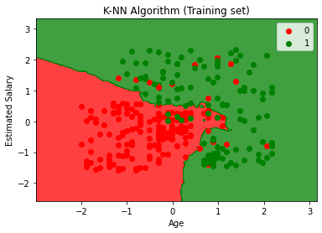

#Visualizing the test set result

from matplotlib.colors import ListedColormap

x_set, y_set = x_test, y_test

x1, x2 = nm.meshgrid(nm.arange(start = x_set[:, 0].min() - 1, stop = x_set[:, 0].max() + 1, step  =0.01), nm.arange(start = x_set[:, 1].min() - 1, stop = x_set[:, 1].max() + 1, step = 0.01))

mtp.contourf(x1, x2, classifier.predict(nm.array([x1.ravel(), x2.ravel()]).T).reshape(x1.shape), alpha = 0.75, cmap = ListedColormap(('red','green' )))

mtp.xlim(x1.min(), x1.max())

mtp.ylim(x2.min(), x2.max())

for i, j in enumerate(nm.unique(y_set)):

    mtp.scatter(x_set[y_set == j, 0], x_set[y_set == j, 1],

        c = ListedColormap(('red', 'green'))(i), label = j)

mtp.title('K-NN algorithm(Test set)')

mtp.xlabel('Age')

mtp.ylabel('Estimated Salary')

mtp.legend()

mtp.show()

from sklearn.metrics import accuracy_score

print ("Accuracy : ", accuracy_score(y_test, y_pred))

**OUTPUT :** *c* argument looks like a single numeric RGB or RGBA sequence, which should be avoided as value-mapping will have precedence in case its length matches with *x* & *y*. Please use the *color* keyword-argument or provide a 2-D array with a single row if you intend to specify the same RGB or RGBA value for all points.

*c* argument looks like a single numeric RGB or RGBA sequence, which should be avoided as value-mapping will have precedence in case its length matches with *x* & *y*. Please use the *color* keyword-argument or provide a 2-D array with a single row if you intend to specify the same RGB or RGBA value for all points.

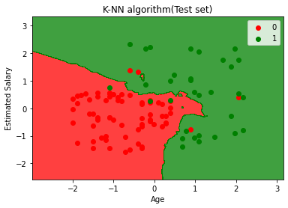

Write a program to implement gradient boosting problem in python

Gradient boosting algorithm

from sklearn import datasets

from sklearn.preprocessing import StandardScaler

from sklearn.model_selection import train_test_split

from sklearn.pipeline import make_pipeline

from sklearn.ensemble import GradientBoostingRegressor

from sklearn.decomposition import PCA

from sklearn.metrics import mean_squared_error

bhp = datasets.load_boston()

X_train, X_test, y_train, y_test = train_test_split(bhp.data, bhp.target, random_state=42, test_size=0.1)

sc = StandardScaler()

X_train_std = sc.fit_transform(X_train)

X_test_std = sc.transform(X_test)

gbr_params = {'n_estimators': 1000,

          'max_depth': 3,

          'min_samples_split': 5,

          'learning_rate': 0.01,

          'loss': 'ls'}

gbr = GradientBoostingRegressor(**gbr_params)

gbr.fit(X_train_std, y_train)

print("Model Accuracy: %.3f" % gbr.score(X_test_std, y_test))

mse = mean_squared_error(y_test, gbr.predict(X_test_std))

print("The mean squared error (MSE) on test set: {:.4f}".format(mse))

output

Model Accuracy: 0.918

The mean squared error (MSE) on test set: 5.1449

import numpy as np

import matplotlib.pyplot as plt

from sklearn.inspection import permutation_importance

feature_importance = gbr.feature_importances_

sorted_idx = np.argsort(feature_importance)

pos = np.arange(sorted_idx.shape[0]) + .5

fig = plt.figure(figsize=(8, 8))

plt.barh(pos, feature_importance[sorted_idx], align='center')

plt.yticks(pos, np.array(bhp.feature_names)[sorted_idx])

plt.title('Feature Importance (MDI)')

result = permutation_importance(gbr, X_test_std, y_test, n_repeats=10,

                                random_state=42, n_jobs=2)

sorted_idx = result.importances_mean.argsort()

fig.tight_layout()

plt.show()

Output

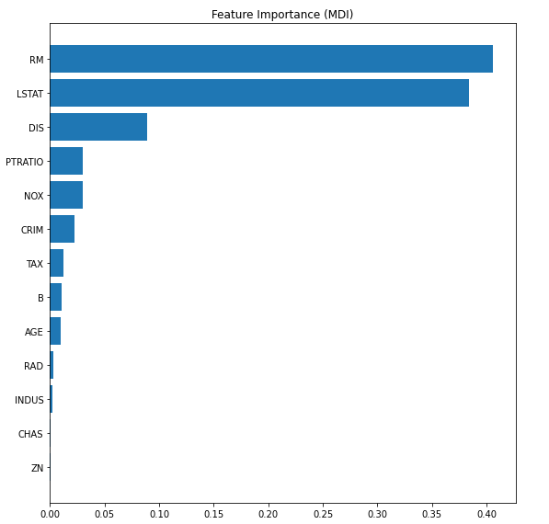

test_score = np.zeros((gbr_params['n_estimators'],), dtype=np.float64)

for i, y_pred in enumerate(gbr.staged_predict(X_test_std)):

    test_score[i] = gbr.loss_(y_test, y_pred)

fig = plt.figure(figsize=(8, 8))

plt.subplot(1, 1, 1)

plt.title('Deviance')

plt.plot(np.arange(gbr_params['n_estimators']) + 1, gbr.train_score_, 'b-',

         label='Training Set Deviance')

plt.plot(np.arange(gbr_params['n_estimators']) + 1, test_score, 'r-',

         label='Test Set Deviance')

plt.legend(loc='upper right')

plt.xlabel('Boosting Iterations')

plt.ylabel('Deviance')

fig.tight_layout()

plt.show()

Output

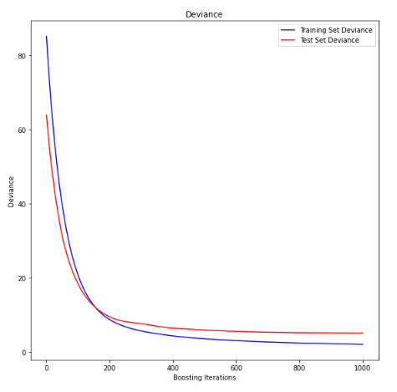

**2. write a program to implement BEST FIRST SEARCH**

from queue import PriorityQueue

import matplotlib.pyplot as plt

import networkx as nx

# for implementing BFS | returns path having lowest cost

def best_first_search(source, target, n):

    visited = [0] * n

    visited[source] = True

    pq = PriorityQueue()

    pq.put((0, source))

    while pq.empty() == False:

        u = pq.get()[1]

        print(u, end=" ") # the path having lowest cost

        if u == target:

            break

        for v, c in graph[u]:

            if visited[v] == False:

                visited[v] = True

                pq.put((c, v))

    print()

# for adding edges to graph

def addedge(x, y, cost):

    graph[x].append((y, cost))

    graph[y].append((x, cost))

v = int(input("Enter the number of nodes: "))

graph = [[] for i in range(v)] # undirected Graph

e = int(input("Enter the number of edges: "))

print("Enter the edges along with their weights:")

for i in range(e):

    x, y, z = list(map(int, input().split()))

    addedge(x, y, z)

source = int(input("Enter the Source Node: "))

target = int(input("Enter the Target/Destination Node: "))

print("\nPath: ", end = "")

best_first_search(source, target, v)

**OUTPUT:**

Enter the number of nodes : 4

Enter the number of edges: 5

Enter the edges along with their weights:

0 1 1

0 2 1

0 3 2

2 3 2

1 3 3

Enter the source node:2

Enter the Target/Destination node:1

Path :2 0 1

**5.Write a program to implement water jug problem using python**

from collections import defaultdict

jug1, jug2, aim = 4, 3, 2

visited = defaultdict(lambda: False)

def waterJugSolver(amt1, amt2):

  if (amt1 == aim and amt2 == 0) or (amt2 == aim and amt1 == 0):

    print(amt1, amt2)

    return True

  if visited[(amt1, amt2)] == False:

    print(amt1, amt2)

    visited[(amt1, amt2)] = True

    return (waterJugSolver(0, amt2) or

        waterJugSolver(amt1, 0) or

        waterJugSolver(jug1, amt2) or

        waterJugSolver(amt1, jug2) or

        waterJugSolver(amt1 + min(amt2, (jug1-amt1)),

        amt2 - min(amt2, (jug1-amt1))) or

        waterJugSolver(amt1 - min(amt1, (jug2-amt2)),

        amt2 + min(amt1, (jug2-amt2))))

  else:

    return False

print("Steps: ")

waterJugSolver(0, 0)

**Output:**

**Steps:**

**0 0**

**4 0**

**4 3**

**0 3**

**3 0**

**3 3**

**4 2**

**0 2**

**True**

**6 . Write a program to implement K-means clustering using random samples**

from copy import deepcopy

import numpy as np # linear algebra

import pandas as pd # data processing, CSV file I/O (e.g. pd.read_csv)

from matplotlib import pyplot as plt

# Set three centers, the model should predict similar results

center_1 = np.array([1,1])

center_2 = np.array([5,5])

center_3 = np.array([8,1])

# Generate random data and center it to the three centers

data_1 = np.random.randn(200, 2) + center_1

data_2 = np.random.randn(200,2) + center_2

data_3 = np.random.randn(200,2) + center_3

data = np.concatenate((data_1, data_2, data_3), axis = 0)

plt.scatter(data[:,0], data[:,1], s=7)

# Number of clusters

k = 3

# Number of training data

n = data.shape[0]

# Number of features in the data

c = data.shape[1]

# Generate random centers, here we use sigma and mean to ensure it represent the whole data

mean = np.mean(data, axis = 0)

std = np.std(data, axis = 0)

centers = np.random.randn(k,c)*std + mean

# Plot the data and the centers generated as random

plt.scatter(data[:,0], data[:,1], s=9,color='c')

plt.scatter(centers[:,0], centers[:,1], marker='*', c='g', s=150)

plt.show()

**Output**

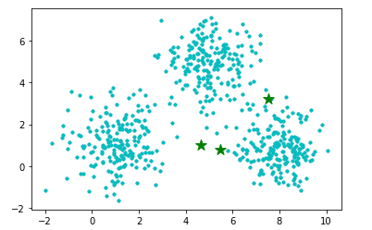

4. Program to implement Depth First Search

# Using a Python dictionary to act as an adjacency list

graph = {

&#39;5&#39; : [&#39;3&#39;,&#39;7&#39;],

&#39;3&#39; : [&#39;2&#39;, &#39;4&#39;],

&#39;7&#39; : [&#39;6&#39;],

&#39;6&#39;: [],

&#39;2&#39; : [&#39;1&#39;],

&#39;1&#39;:[],

&#39;4&#39; : [&#39;8&#39;],

&#39;8&#39; : []

}

visited = set() # Set to keep track of visited nodes of graph.

def dfs(visited, graph, node): #function for dfs

if node not in visited:

print (node)

visited.add(node)

for neighbour in graph[node]:

dfs(visited, graph, neighbour)

# Driver Code

print(&quot;Following is the Depth-First Search&quot;)

dfs(visited, graph, &#39;5&#39;)

OUTPUT

Following is the Depth-First Search

5

3

2

1

4

8

7

6